Chapter 32
A Macroeconomic Theory of the Open Economy
Multiple Choice
1. Over the past two decades, the United States has
a. generally had, or been very near to a trade balance.
b. had trade deficits in about as many years as it has trade surpluses.
c. persistently had a trade deficit.
d. persistently had a trade surplus.
ANS: C PTS: 1 DIF: 1 REF: 14-0
TOP: Budget deficit MSC: Definitional
2. Many U.S. business leaders argue that the current state of U.S. net exports is the result of
a. U.S. export subsidies.
b. free trade policies of foreign governments.
c. unproductive U.S. workers.
d. unfair foreign competition.
ANS: D PTS: 1 DIF: 1 REF: 14-0
TOP: U.S. trade MSC: Definitional
3. The open-economy macroeconomic model includes
a. only the market for loanable funds.
b. only the market for foreign-currency exchange.
c. both the market for loanable funds and the market for foreign-currency exchange.
d. neither the market for loanable funds or the market for foreign-currency exchange.
ANS: C PTS: 1 DIF: 1 REF: 14-0
TOP: Open-economy macroeconomic model MSC: Definitional
4. The open-economy macroeconomic model examines the determination of
a. the output growth rate and the real interest rate.
b. unemployment and the exchange rate.
c. the output growth rate and the inflation rate.
d. the trade balance and the exchange rate.
ANS: D PTS: 1 DIF: 1 REF: 14-0
TOP: Open-economy macroeconomic model MSC: Definitional
5. The open-economy macroeconomic model takes
a. GDP, but not the price level as given.
b. the price level, but not GDP as given.
c. both the price level and GDP as given.
d. the price level and GDP as variables to be determined by the model.
ANS: C PTS: 1 DIF: 1 REF: 14-1
TOP: Open-economy macroeconomic model MSC: Definitional
6. In an open economy, the market for loanable funds equates national saving with
a. domestic investment.
b. net capital outflow.
c. the sum of national consumption and government spending.
d. the sum of domestic investment and net capital outflow.
ANS: D PTS: 1 DIF: 1 REF: 14-1
TOP: Market for loanable funds MSC: Interpretive
7. In an open economy, the market for loanable funds equates national saving with
a. domestic investment.
b. net capital outflow.
c. national consumption minus domestic investment.
d. None of the above is correct.
ANS: D PTS: 1 DIF: 1 REF: 14-1
TOP: Market for loanable funds MSC: Interpretive
8. In the open-economy macroeconomic model, the market for loanable funds identity can be written as
a. S = I
b. S = NCO
c. S = I + NCO
d. S + I = NCO
ANS: C PTS: 1 DIF: 1 REF: 14-1
TOP: Market for loanable funds MSC: Definitional
9. In the open-economy macroeconomic model, the supply of loanable funds comes from
a. national saving.
b. private saving.
c. domestic investment.
d. the sum of domestic investment and net capital outflow.
ANS: A PTS: 1 DIF: 1 REF: 14-1
TOP: Market for loanable funds MSC: Definitional
10. In the open-economy macroeconomic model, the demand for loanable funds comes from
a. domestic investment.
b. net exports.
c. net capital outflow.
d. the sum of net capital outflow and domestic investment.
ANS: D PTS: 1 DIF: 1 REF: 14-1
TOP: Market for loanable funds MSC: Definitional
11. The purchase of a capital asset adds to the demand for loanable funds
a. only if the asset is located at home.
b. only if the asset is located abroad.
c. whether the asset is located at home or abroad.
d. None of the above is correct.
ANS: C PTS: 1 DIF: 1 REF: 14-1
TOP: Market for loanable funds MSC: Applicative
12. U.S. corporation Well’s Petroleum borrows money to build an oil well in Texas and to build another in Venezuela.
a. The borrowing for the well in the U.S. and the well in Venezuela both count as part of the demand for loanable funds in the U.S. market.
b. Neither the borrowing for the well in the U.S. nor the well in Venezuela count as part of the demand for loanable funds in the U.S. market.
c. The borrowing for the well in the U.S. counts as part of the demand for loanable funds in the U.S. The borrowing for the well in Venezuela does not count as part of the demand for loanable funds in the U.S. market.
d. The borrowing for the well in Venezuela counts as part of the demand for loanable funds in the U.S. The borrowing for the well in the US. does not counts as part of the demand for loanable funds in the U.S. market.
ANS: A PTS: 1 DIF: 2 REF: 14-1
TOP: Market for loanable funds MSC: Interpretive
13. Other things the same, a higher real interest rate raises the quantity of
a. domestic investment.
b. net capital outflow.
c. loanable funds demanded.
d. loanable funds supplied.
ANS: D PTS: 1 DIF: 1 REF: 14-1
TOP: Market for loanable funds MSC: Applicative
14. Other things the same, a lower real interest rate decreases the quantity of
a. loanable funds demanded.
b. loanable funds supplied.
c. domestic investment.
d. net capital outflow.
ANS: B PTS: 1 DIF: 1 REF: 14-1
TOP: Market for loanable funds MSC: Applicative
15. An increase in the real interest rate
a. discourages people from saving and so increases the quantity of loanable funds demanded.
b. discourages people from saving and so decreases the quantity of loanable funds demanded.
c. encourages people to save and so increases the quantity of loanable funds supplied.
d. encourages people to save and so decreases the quantity of loanable funds supplied.
ANS: C PTS: 1 DIF: 1 REF: 14-1
TOP: Market for loanable funds MSC: Applicative
16. A fall in the real interest rate
a. increases the quantity of loanable funds demanded because firms will want to borrow more
b. decreases the quantity of loanable funds demanded because firms will want to borrow less.
c. increases the quantity of loanable funds supplied because firms will want to borrow more.
d. decreases the quantity of loanable funds supplied because firms will want to borrow less.
ANS: A PTS: 1 DIF: 1 REF: 14-1
TOP: Market for loanable funds MSC: Applicative
17. An increase in real interest rates in the United States
a. discourages both U.S. and foreign residents from buying U.S. assets.
b. encourages both U.S. and foreign residents to buy U.S. assets.
c. encourages U.S. residents to buy U.S. assets, but discourages foreign residents from buying U.S. assets.
d. encourages foreign residents to buy U.S. assets, but discourages U.S. residents from buying U.S. assets.
ANS: B PTS: 1 DIF: 1 REF: 14-1
TOP: Market for loanable funds MSC: Applicative
18. Which of the following would be consistent with an increase in the U.S. real interest rate?
a. a Swiss bank purchases a U.S. bond instead of the German bond it had considered purchasing.
b. firms decide to do more investment spending.
c. a U.S. citizen decides to put less money in his savings account than he had planned to.
d. All of the above are consistent.
ANS: A PTS: 1 DIF: 1 REF: 14-1
TOP: Market for loanable funds MSC: Applicative
19. If interest rates rose more in France than in the U.S., then other things the same
a. U.S. citizens would buy more French bonds and French citizens would buy more U.S. bonds.
b. U.S. citizens would buy more French bonds and French citizens would buy fewer U.S. bonds.
c. U.S. citizens would buy fewer French bonds and French citizens would buy more U.S. bonds.
d. U.S. citizens would buy fewer French bonds and French citizens would buy fewer U.S. bonds.
ANS: B PTS: 1 DIF: 1 REF: 14-1
TOP: Market for loanable funds MSC: Applicative
20. An increase in the U.S. real interest rate induces
a. Americans to buy more foreign assets, which increases U.S. net capital outflow.
b. Americans to buy more foreign assets, which reduces U.S. net capital outflow.
c. foreigners to buy more U.S. assets, which reduces U.S. net capital outflow.
d. foreigners to buy more U.S. assets, which increases U.S. net capital outflow.
ANS: C PTS: 1 DIF: 2 REF: 14-1
TOP: Net capital outflow MSC: Analytical
21. Other things the same, an increase in the interest rate would tend to reduce
a. domestic investment, but not net capital outflow.
b. net capital outflow, but not domestic investment.
c. both domestic investment and net capital outflow.
d. neither domestic investment nor not capital outflow.
ANS: C PTS: 1 DIF: 2 REF: 14-1
TOP: Market for loanable funds MSC: Interpretive
22. In an open economy, the demand for loanable funds comes from
a. only those who want to borrow funds to buy domestic capital goods.
b. only those who want to borrow funds to buy foreign assets.
c. those who want to borrow funds to buy either domestic capital goods or foreign assets.
d. neither those who want to borrow funds to buy domestic capital goods nor those who want to borrow funds to buy foreign assets.
ANS: C PTS: 1 DIF: 1 REF: 14-1
TOP: Market for loanable funds MSC: Definitional
23. In an open economy the supply of loanable funds comes from
a. national saving. Demand comes from only domestic investment.
b. national saving. Demand comes from domestic investment and net capital outflow.
c. Only net capital outflow. Demand for loanable funds comes from national saving.
d. domestic investment and net capital outflow. Demand for loanable funds comes from national saving.
ANS: B PTS: 1 DIF: 2 REF: 14-1
TOP: Market for loanable funds MSC: Definitional
24. The supply of loanable funds comes from
a. national saving.
b. national saving and domestic investment.
c. domestic investment and net capital outflow.
d. national saving, domestic investment, and net capital outflow.
ANS: A PTS: 1 DIF: 1 REF: 14-1
TOP: Market for loanable funds MSC: Definitional
25. If the quantity of loanable funds supplied is greater than the quantity demanded, then
a. there is a shortage of loanable funds and the interest rate will fall.
b. there is a shortage of loanable funds and the interest rate will rise.
c. there is a surplus of loanable funds and the interest rate will fall.
d. there is a surplus of loanable funds and the interest rate will rise.
ANS: C PTS: 1 DIF: 2 REF: 14-1
TOP: Market for loanable funds MSC: Analytical
26. If there is a surplus of loanable funds, the quantity demanded is
a. greater than the quantity supplied and the interest rate will rise.
b. greater than the quantity supplied and the interest rate will fall.
c. less than the quantity supplied and the interest rate will rise.
d. less than the quantity supplied and the interest rate will fall.
ANS: D PTS: 1 DIF: 2 REF: 14-1
TOP: Market for loanable funds MSC: Analytical
27. If the quantity of loanable funds demanded is greater than the quantity of loanable funds supplied
a. there is a surplus and the interest rate will rise.
b. there is a surplus and the interest rate will fall.
c. there is a shortage and the interest rate will rise.
d. there is a shortage and the interest rate will fall.
ANS: C PTS: 1 DIF: 2 REF: 14-1
TOP: Market for loanable funds MSC: Analytical
28. If there is a shortage of loanable funds,
a. the demand for loanable funds will shift right so the interest rate rises.
b. the supply of loanable funds will shift left so the interest rate falls.
c. there will be no shifts of the curves, but the interest rate rises.
d. there will be no shifts of the curves, but the interest rate falls.
ANS: C PTS: 1 DIF: 1 REF: 14-1
TOP: Market for loanable funds MSC: Analytical
29. Suppose the U.S. supply of loanable funds shifts left. This will
a. increase U.S. net capital outflow and increase the quantity of loanable funds demanded.
b. increase U.S. net capital outflow and decrease the quantity of loanable funds demanded.
c. decrease U.S. net capital outflow and increase the quantity of loanable funds demanded.
d. decrease U.S. net capital outflow and decrease the quantity of loanable funds demanded.
ANS: D PTS: 1 DIF: 3 REF: 14-1
TOP: Market for loanable funds MSC: Interpretive
30. Which of the following would make both the equilibrium interest rate and the equilibrium quantity of loanable funds increase?
a. The demand for loanable funds shifts right.
b. The demand for loanable funds shifts left.
c. The supply of loanable funds shifts right.
d. The supply of loanable funds shifts left.
ANS: A PTS: 1 DIF: 2 REF: 14-1
TOP: Market for loanable funds MSC: Analytical
31. Which of the following would make both the equilibrium interest rate and the equilibrium quantity of loanable funds decrease?
a. The demand for loanable funds shifts right.
b. The demand for loanable funds shifts left.
c. The supply of loanable funds shifts right.
d. The supply of loanable funds shifts left.
ANS: B PTS: 1 DIF: 2 REF: 14-1
TOP: Market for loanable funds MSC: Analytical
32. Which of the following would make the equilibrium interest rate increase and the equilibrium quantity of funds decrease?
a. The supply of loanable funds shifts right.
b. The supply of loanable funds shifts left.
c. The demand for loanable funds shifts right.
d. The demand for loanable funds shifts left.
ANS: B PTS: 1 DIF: 2 REF: 14-1
TOP: Market for loanable funds MSC: Analytical
33. Which of the following would make the equilibrium interest rate decrease and the equilibrium quantity of loanable funds increase?
a. The supply of loanable funds shifts right.
b. The supply of loanable funds shifts left.
c. The demand for loanable funds shifts right.
d. The demand for loanable funds shifts left.
ANS: A PTS: 1 DIF: 2 REF: 14-1
TOP: Market for loanable funds MSC: Analytical
34. At the equilibrium interest rate in the open economy macroeconomic model, the amount that people want to save equals the desired quantity of
a. net capital outflow.
b. domestic investment.
c. net capital outflow plus domestic investment.
d. foreign currency supplied.
ANS: C PTS: 1 DIF: 1 REF: 14-1
TOP: Market for loanable funds MSC: Applicative
35. At the equilibrium interest rate in the open economy macroeconomic model, the equilibrium quantity of loanable funds equals
a. net capital outflow.
b. domestic investment.
c. foreign currency supplied.
d. national saving.
ANS: D PTS: 1 DIF: 1 REF: 14-1
TOP: Market for loanable funds MSC: Applicative
36. In the open-economy macroeconomic model, other things the same, a decrease in the interest rate shifts
a. the demand for dollars in the market for foreign-currency exchange to the right.
b. the demand for dollars in the market for foreign-currency exchange to the left.
c. the supply of dollars in the market for foreign-currency exchange to the right.
d. the supply of dollars in the market for foreign-currency exchange to the left.
ANS: C PTS: 1 DIF: 2 REF: 14-2
TOP: Open-economy macroeconomic model | Market for foreign-currency exchange MSC: Interpretive
37. In an open economy,
a. net capital outflow = imports.
b. net capital outflow = net exports.
c. net capital outflow = exports.
d. None of the above is correct.
ANS: B PTS: 1 DIF: 1 REF: 14-1
TOP: Net exports | Net capital outflow MSC: Definitional
Figure 14-1
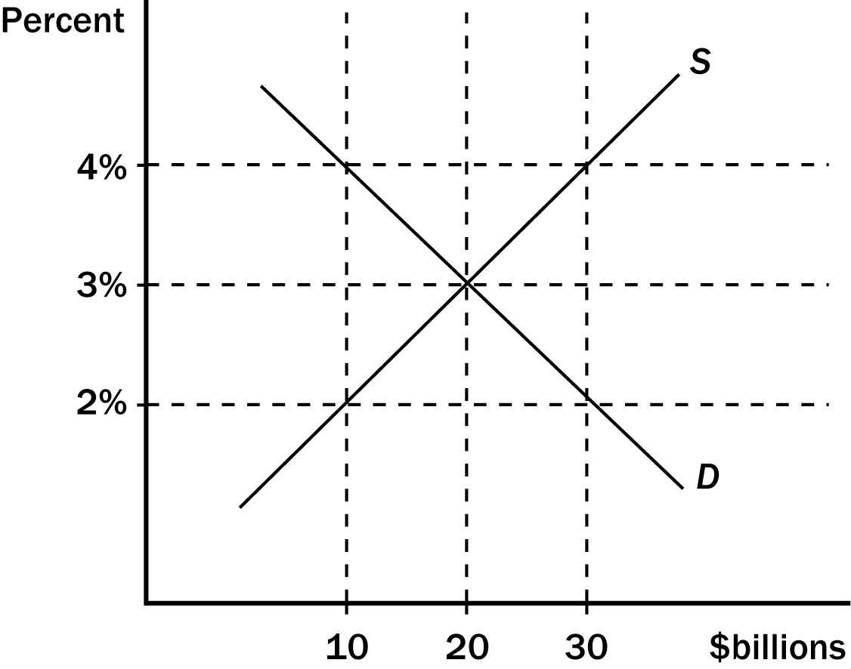
38. Refer to Figure 14-1. The loanable funds market is in equilibrium at
a. 1 percent, $30 billion.
b. 2 percent, $20 billion.
c. 4 percent, $10 billion.
d. None of the above is correct.
ANS: B PTS: 1 DIF: 1 REF: 14-1
TOP: Market for loanable funds MSC: Applicative
39. Refer to Figure 14-1. In the Figure shown, if the real interest rate is 3 percent, the quantity of loanable funds demanded is
a. $10 billion, and the quantity supplied is 20.
b. $10 billion, and the quantity supplied is 30.
c. $30 billion, and the quantity supplied is 10.
d. $30 billion, and the quantity supplied is 20.
ANS: B PTS: 1 DIF: 1 REF: 14-1
TOP: Market for loanable funds MSC: Applicative
40. Refer to Figure 14-1. In the Figure shown, if the real interest rate is 1 percent, there will be a
a. surplus of $10 billion.
b. surplus of $20 billion.
c. shortage of $10 billion.
d. shortage of $20 billion.
ANS: D PTS: 1 DIF: 1 REF: 14-1
TOP: Market for loanable funds MSC: Analytical
41. Refer to Figure 14-1. In the Figure shown, if the real interest rate is 1 percent, there will be pressure for
a. the real interest rate to rise.
b. the demand for loanable funds curve to shift right.
c. the supply for loanable funds curve to shift left.
d. All of the above are correct.
ANS: A PTS: 1 DIF: 1 REF: 14-1
TOP: Market for loanable funds MSC: Applicative
42. If net exports are positive, then
a. exports are greater than imports.
b. net capital outflow is negative.
c. Both of the above are correct.
d. Neither of the above is correct.
ANS: A PTS: 1 DIF: 1 REF: 14-1
TOP: Net exports | Net capital outflow MSC: Interpretive
43. If net exports are negative, then
a. net capital outflow is positive, so foreign assets bought by Americans are greater than American assets bought by foreigners.
b. net capital outflow is positive, so American assets bought by foreigners are greater than foreign assets bought by Americans.
c. net capital outflow is negative, so foreign assets bought by Americans are greater than American assets bought by foreigners.
d. net capital outflow is negative, so American assets bought by foreigners are greater than foreign assets bought by Americans.
ANS: D PTS: 1 DIF: 2 REF: 14-1
TOP: Net exports | Net capital outflow MSC: Interpretive
44. If net exports are positive, then
a. net capital outflow is positive, so foreign assets bought by Americans are greater than American assets bought by foreigners.
b. net capital outflow is positive, so American assets bought by foreigners are greater than foreign assets bought by Americans.
c. net capital outflow is negative, so foreign assets bought by Americans are greater than American assets bought by foreigners.
d. net capital outflow is negative, so American assets bought by foreigners are greater than foreign assets bought by Americans.
ANS: A PTS: 1 DIF: 2 REF: 14-1
TOP: Net exports | Net capital outflow MSC: Interpretive
45. In the market for foreign-currency exchange in the open economy macroeconomic model, the amount of net capital outflow represents the quantity of dollars
a. supplied for the purpose of selling assets domestically.
b. supplied for the purpose of buying assets abroad.
c. demanded for the purpose of buying U.S. net exports of goods and services.
d. demanded for the purpose of importing foreign goods and services.
ANS: B PTS: 1 DIF: 2 REF: 14-1
TOP: Market for foreign-currency exchange MSC: Interpretive
46. In the open economy macroeconomic model net capital outflow is equal to the quantity of
a. dollars supplied in the foreign exchange market.
b. dollars demand in the foreign exchange market.
c. funds supplied in the loanable funds market.
d. None of the above is correct.
ANS: A PTS: 1 DIF: 1 REF: 14-1
TOP: Market for foreign-currency exchange MSC: Interpretive
47. Net capital outflow is equal to
a. national saving minus the trade balance.
b. domestic investment plus national saving.
c. national saving minus domestic investment.
d. domestic investment minus national saving.
ANS: C PTS: 1 DIF: 2 REF: 14-1
TOP: Net capital outflow MSC: Definitional
48. The value of net exports equals the value of
a. national saving.
b. public saving.
c. national saving - net exports.
d. national saving - domestic investment.
ANS: D PTS: 1 DIF: 3 REF: 14-1
TOP: Net exports MSC: Definitional
49. Suppose that the real exchange rate is such that the market for foreign-currency exchange has a surplus
a. this will lead to an appreciation of the dollar, an increase in U.S. net exports, and so an increase in the quantity of dollars demanded in the foreign exchange market.
b. this will lead to an appreciation of the dollar, a decrease in U.S. net exports, and so a decrease in the quantity of dollars demanded in the foreign exchange market.
c. this will lead to a depreciation of the dollar, an increase in U.S. net exports, and so an increase in the quantity of dollars demanded in the foreign exchange market.
d. this will lead to a depreciation of the dollar, a decrease in U.S. net exports, and so a decrease in the quantity of dollars demanded in the foreign exchange market.
ANS: C PTS: 1 DIF: 2 REF: 14-1
TOP: Market for foreign-currency exchange MSC: Analytical
50. Which of the following is included in the demand for dollars in the market for foreign-currency exchange in the open-economy macroeconomic model?
a. A firm in Mexico wants to buy corn from a U.S. firm.
b. A Japanese bank desires to purchase U.S. Treasury securities.
c. An U.S. citizen wants to buy a bond issued by a Mexican corporation.
d. All of the above are correct.
ANS: A PTS: 1 DIF: 3 REF: 14-1
TOP: Market for foreign-currency exchange MSC: Interpretive
51. Which of the following is included in the supply of dollars in the market for foreign-currency exchange in the open-economy macroeconomic model?
a. A retail outlet in Russia wants to buy semi-conductors from a U.S. manufacturer.
b. A U.S. bank loans dollars to Blair, a U.S. resident, who wants to purchase a new house in the United States.
c. A U.S. based mutual fund wants to purchase bonds issued by an Italian corporation.
d. All of the above are correct.
ANS: C PTS: 1 DIF: 3 REF: 14-1
TOP: Market for foreign-currency exchange MSC: Applicative
52. Which of the following would tend to shift the supply of dollars in the market for foreign-currency exchange in the open-economy macroeconomic model to the right?
a. The exchange rate rises.
b. The exchange rate falls.
c. The expected rate of return on U.S. assets rises.
d. The expected rate of return on U.S. assets falls.
ANS: D PTS: 1 DIF: 2 REF: 14-1
TOP: Market for foreign-currency exchange MSC: Applicative
53. Which of the following would tend to shift the supply of dollars in the market for foreign-currency exchange of the open-economy macroeconomic model to the left?
a. The exchange rate rises.
b. The exchange rate falls.
c. The expected rate of return on U.S. assets rises.
d. The expected rate of return on U.S. assets falls.
ANS: C PTS: 1 DIF: 2 REF: 14-1
TOP: Market for foreign-currency exchange MSC: Applicative
54. If for some reason Americans wished to purchase more foreign assets, then other things the same
a. both the real exchange rate and the quantity of dollars exchanged in the market for foreign-currency exchange would fall.
b. both the real exchange rate and the quantity of dollars exchanged in the market for foreign-currency would rise.
c. the real exchange rate would rise and the quantity of dollars exchanged in the market for foreign-currency would fall.
d. the real exchange rate would fall and the quantity of dollars exchanged in the market for foreign-currency would rise.
ANS: D PTS: 1 DIF: 2 REF: 14-1
TOP: Market for foreign-currency exchange MSC: Applicative
55. You see on the Internet that the U.S. exchange rate has fallen. This might have been caused by
a. a decrease in the demand for or a decrease in the supply of dollars in the market for foreign-currency exchange.
b. a decrease in the demand for or an increase in the supply of dollars in the market for foreign-currency exchange.
c. an increase in the demand for or a decrease in the supply of dollars in the market for foreign-currency exchange.
d. an increase in the demand for or a increase in the supply of dollars in the market for foreign-currency exchange.
ANS: B PTS: 1 DIF: 1 REF: 14-2
TOP: Market for foreign-currency exchange MSC: Applicative
56. At a given real exchange rate, which of the following, by itself, would increase the supply of dollars in the market for foreign-currency exchange?
a. foreign citizens buy more U.S. bonds
b. U.S. citizens buy more foreign bonds
c. foreign citizens buy more U.S. goods
d. U.S. citizens buy more foreign goods
ANS: B PTS: 1 DIF: 2 REF: 14-1
TOP: Market for foreign-currency exchange MSC: Interpretive
57. The amount of dollars demanded in the market for foreign-currency exchange at a given real exchange rate increases if
a. either U.S. imports or exports increase.
b. either U.S. imports or exports decrease.
c. either U.S. imports increase or U.S. exports decrease.
d. either U.S. imports decrease or U.S. exports increase.
ANS: D PTS: 1 DIF: 2 REF: 14-1
TOP: Market for foreign-currency exchange MSC: Interpretive
58. The real exchange rate measures the
a. price of domestic currency relative to foreign currency.
b. price of domestic goods relative to the price of foreign goods.
c. rate of domestic and foreign interest.
d. None of the above is correct.
ANS: B PTS: 1 DIF: 1 REF: 14-1
TOP: Real exchange rate MSC: Definitional
59. The price that balances supply and demand in the market for foreign-currency exchange in the open-economy macroeconomic model is the
a. nominal exchange rate.
b. nominal interest rate.
c. real exchange rate.
d. real interest rate.
ANS: C PTS: 1 DIF: 1 REF: 14-1
TOP: Market for foreign-currency exchange MSC: Definitional
60. In the market for foreign-currency exchange in the open-economy macroeconomic model, a higher U.S. real exchange rate makes
a. U.S. goods more expensive relative to foreign goods and reduces the quantity of dollars supplied.
b. U.S. goods more expensive relative to foreign goods and reduces the quantity of dollars demanded.
c. foreign goods more expensive relative to U.S. goods and reduces the quantity of dollars supplied.
d. foreign goods more expensive relative to U.S. goods and reduces the quantity of dollars demanded.
ANS: B PTS: 1 DIF: 1 REF: 14-1
TOP: Market for foreign-currency exchange MSC: Applicative
61. In the open-economy macroeconomic model, equilibrium is determined by the equality between the supply of dollars which comes from
a. U.S. national saving and the demand for dollars for U.S. net exports.
b. U.S. net capital outflow and the demand for dollars for U.S. net exports.
c. domestic investment and the demand for U.S. net exports.
d. foreign demand for U.S. goods and U.S. demand for foreign goods.
ANS: B PTS: 1 DIF: 2 REF: 14-1
TOP: Market for foreign-currency exchange MSC: Definitional
62. When the real exchange rate for the dollar appreciates, U.S. goods become
a. less expensive relative to foreign goods, which makes exports rise and imports fall.
b. less expensive relative to foreign goods, which makes exports fall and imports rise.
c. more expensive relative to foreign goods, which makes exports rise and imports fall.
d. more expensive relative to foreign goods, which makes exports fall and imports rise.
ANS: D PTS: 1 DIF: 2 REF: 14-1
TOP: Market for foreign-currency exchange MSC: Analytical
63. When the real exchange rate for the dollar depreciates, U.S. goods become
a. less expensive relative to foreign goods, which makes exports rise and imports fall.
b. less expensive relative to foreign goods, which makes exports fall and imports rise.
c. more expensive relative to foreign goods, which makes exports rise and imports fall.
d. more expensive relative to foreign goods, which makes exports fall and imports rise.
ANS: A PTS: 1 DIF: 2 REF: 14-1
TOP: Market for foreign-currency exchange MSC: Analytical
64. If the real exchange rate for the dollar is above the equilibrium level, the quantity of dollars supplied in the market for foreign-currency exchange is
a. greater than the quantity demanded and the dollar will appreciate.
b. greater than the quantity demanded and the dollar will depreciate.
c. less than the quantity demanded and the dollar will appreciate.
d. less than the quantity demanded and the dollar will depreciate.
ANS: B PTS: 1 DIF: 2 REF: 14-1
TOP: Market for foreign-currency exchange MSC: Analytical
65. If the real exchange rate for the dollar is below the equilibrium level, the quantity of dollars supplied in the market for foreign-currency exchange is
a. less than the quantity demanded and the dollar will appreciate.
b. less than the quantity demanded and the dollar will depreciate.
c. greater than the quantity demanded and the dollar will appreciate.
d. greater than the quantity demanded and the dollar will depreciate.
ANS: A PTS: 1 DIF: 2 REF: 14-1
TOP: Market for foreign-currency exchange MSC: Analytical
66. In the open-economy macroeconomic model, the quantity of dollars demanded in the market for foreign-currency exchange
a. depends on the real exchange rate. The quantity of dollars supplied in the foreign-exchange market depends on the real interest rate.
b. depends on the real interest rate. The quantity of dollars supplied in the foreign-exchange market depends on the real exchange rate.
c. and the quantity of dollars supplied in the market for foreign-currency exchange depend on the real exchange rate.
d. and the quantity of dollars supplied in the market for foreign-currency exchange depend on the real interest rate.
ANS: A PTS: 1 DIF: 3 REF: 14-1
TOP: Market for foreign-currency exchange MSC: Analytical
67. Net capital outflow
a. is a source of the supply of loanable funds, and the source of the supply of dollars in the foreign exchange market.
b. is a source of the supply of loanable funds, and a source of the demand for dollars in the foreign exchange market.
c. is a part of the demand for loanable funds, and the source of the supply of dollars in the foreign exchange market.
d. is a part of the demand for loanable funds, and a source of the demand for dollars in the foreign exchange market.
ANS: C PTS: 1 DIF: 1 REF: 14-2
TOP: Open-economy macroeconomic model MSC: Interpretive
68. The theory of purchasing-power parity implies that the demand curve for foreign-currency exchange is
a. downward sloping.
b. upward sloping.
c. horizontal.
d. vertical.
ANS: C PTS: 1 DIF: 2 REF: 14-1
TOP: Market for foreign-currency exchange MSC: Analytical
69. The variable that links the market for loanable funds and the market for foreign-currency exchange is
a. net capital outflow.
b. national saving.
c. exports.
d. domestic investment.
ANS: A PTS: 1 DIF: 2 REF: 14-2
TOP: Open-economy macroeconomic model | Net capital outflow MSC: Definitional
70. Which of the following is correct in an open economy?
a. S = I
b. S = NX + NCO
c. S = NCO
d. S = I + NCO
ANS: D PTS: 1 DIF: 1 REF: 14-2
TOP: Saving in an open economy MSC: Definitional
71. In the open-economy macroeconomic model, the key determinant of net capital outflow is the
a. nominal exchange rate.
b. nominal interest rate.
c. real exchange rate.
d. real interest rate.
ANS: D PTS: 1 DIF: 1 REF: 14-2
TOP: Open-economy macroeconomic model | Net capital outflow MSC: Definitional
72. When the U.S. real interest rate falls, owning U.S. assets is
a. less attractive and so U.S. net capital outflow rises.
b. less attractive and so U.S. net capital outflow falls.
c. more attractive and so U.S. net capital outflow rises.
d. more attractive and so U.S. net capital outflow falls.
ANS: A PTS: 1 DIF: 1 REF: 14-2
TOP: Open-economy macroeconomic model | Net capital outflow MSC: Applicative
73. If a U.S. resident wants to buy a foreign bond, his actions are included
a. in the U.S. supply of loanable funds and the supply of dollars in the market for foreign-currency exchange.
b. in the U.S. supply of loanable funds and the demand for dollars in the market for foreign-currency exchange.
c. in the U.S. demand for loanable funds and the supply of dollars in the market for foreign-currency exchange.
d. in the U.S. demand for loanable funds and the supply of dollars in the market for foreign-currency exchange.
ANS: C PTS: 1 DIF: 2 REF: 14-2
TOP: Open-economy macroeconomic model MSC: Interpretive
74. Other things the same, if the Canadian real interest rate were to increase, Canadian net capital outflow
a. and net capital outflow of other countries would rise.
b. and net capital outflow of other countries would fall.
c. would rise, while net capital outflow of other countries would fall.
d. would fall, while net capital outflow of other countries would rise.
ANS: D PTS: 1 DIF: 1 REF: 14-2
TOP: Open-economy macroeconomic model | Net capital outflow MSC: Applicative
75. In the open-economy macroeconomic model, which of the following would make India's net capital outflow decrease?
a. a decrease in U.S. interest rates.
b. a decrease in Indian interest rates.
c. an appreciation of the Indian rupee.
d. None of the above is correct.
ANS: A PTS: 1 DIF: 2 REF: 14-2
TOP: Net capital outflow | Open-economy macroeconomic model MSC: Applicative
76. In the open-economy macroeconomic model, if a country's interest rate increases, its net capital outflow
a. and the real exchange rate increase.
b. and the real exchange rate decrease.
c. increases and the real exchange rate decreases.
d. decreases and the real exchange rate increases.
ANS: D PTS: 1 DIF: 2 REF: 14-2
TOP: Open-economy macroeconomic model | Market for foreign-currency exchange MSC: Applicative
77. In the open-economy macroeconomic model, if the supply of loanable funds increases, net capital outflow
a. and the real exchange rate increase.
b. and the real exchange rate decrease.
c. increases and the real exchange rate decreases.
d. decreases and the real exchange rate increases.
ANS: C PTS: 1 DIF: 3 REF: 14-2
TOP: Open-economy macroeconomic model MSC: Analytical
78. In the open-economy macroeconomic model, if the supply of loanable funds increases, the interest rate
a. and the real exchange rate increase.
b. and the real exchange rate decrease.
c. increases and the real exchange rate decreases.
d. decreases and the real exchange rate increases.
ANS: B PTS: 1 DIF: 3 REF: 14-2
TOP: Open-economy macroeconomic model MSC: Analytical
Figure 14-2
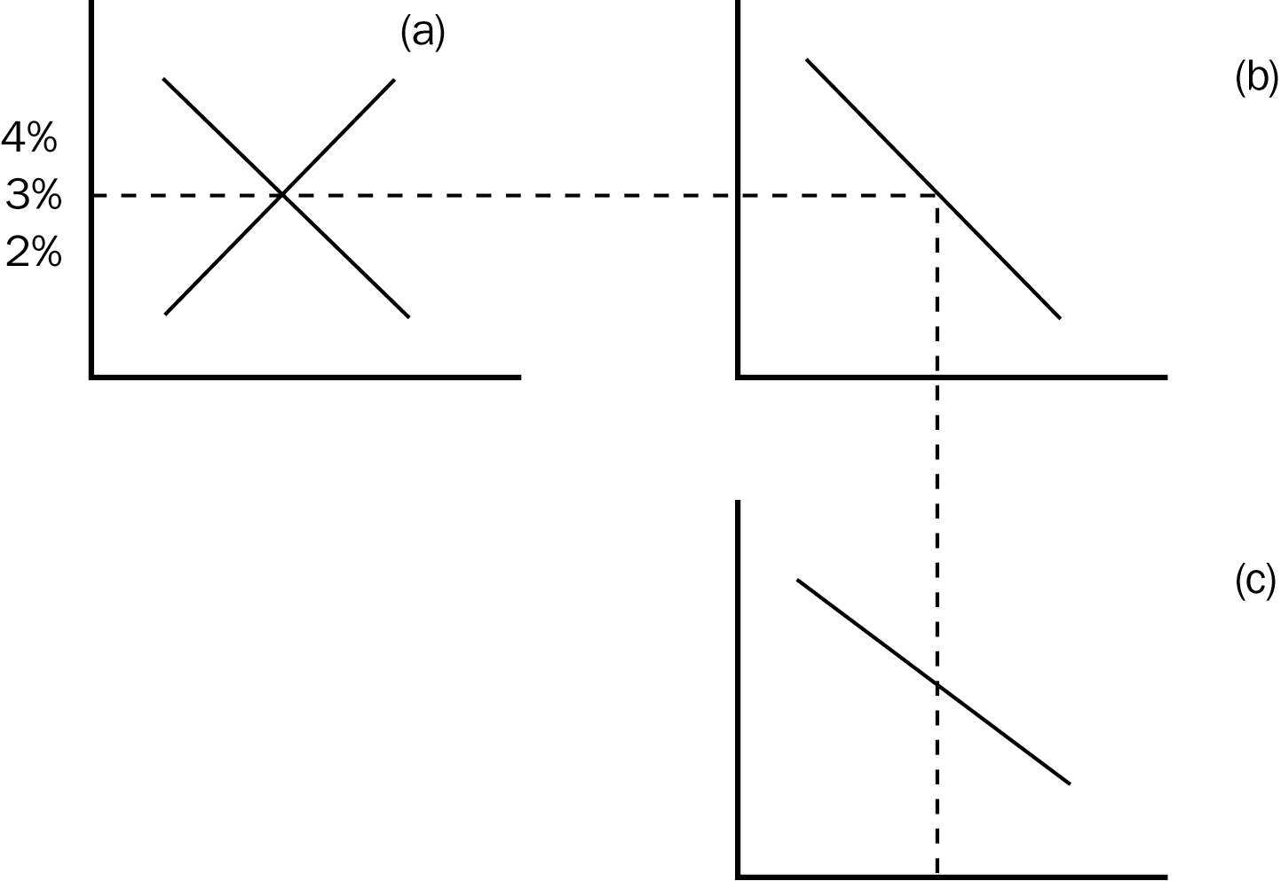
79. Refer to Figure 14-2. National saving is represented by the
a. demand curve in panel a.
b. demand curve in panel c.
c. supply curve in panel a.
d. supply curve in panel c.
ANS: C PTS: 1 DIF: 1 REF: 14-2
TOP: Market for loanable funds MSC: Applicative
80. Refer to Figure 14-2. Domestic investment plus net capital outflow is represented by the
a. demand curve in panel a.
b. demand curve in panel c.
c. supply curve in panel a.
d. None of the above is correct.
ANS: A PTS: 1 DIF: 1 REF: 14-2
TOP: Market for loanable funds MSC: Definitional
81. Refer to Figure 14-2. At an interest rate of 3 percent, the diagram indicates that
a. there is a surplus in the market for foreign-currency exchange.
b. national saving equals domestic investment.
c. net capital outflow + domestic investment = national saving.
d. the market for foreign-currency exchange the quantity of dollars supplied equals the quantity of dollars demanded.
ANS: C PTS: 1 DIF: 2 REF: 14-2
TOP: Market for loanable funds MSC: Interpretive
82. Refer to Figure 14-2. The curve in panel b shows that as the interest rate rises,
a. domestic investment declines.
b. net capital outflow declines.
c. net capital outflow and domestic investment decline.
d. None of the above is correct.
ANS: B PTS: 1 DIF: 2 REF: 14-2
TOP: Market for loanable funds MSC: Interpretive
83. Refer to Figure 14-2. Which curve is determined by net capital outflow only?
a. the demand curve in panel a.
b. the demand curve in panel c.
c. the supply curve in panel a.
d. the supply curve in panel c.
ANS: D PTS: 1 DIF: 2 REF: 14-2
TOP: Market for loanable funds MSC: Interpretive
84. Refer to Figure 14-2. Which curve shows the relation between the exchange rate and net exports?
a. the demand curve in panel a.
b. the demand curve in panel c.
c. the supply curve in panel a.
d. the supply curve in panel c.
ANS: B PTS: 1 DIF: 2 REF: 14-2
TOP: Market for loanable funds MSC: Interpretive
85. Because a government budget deficit represents
a. negative public saving, it increases national savings.
b. negative public saving, it decreases national savings.
c. positive public saving, it increases national savings.
d. positive public saving, it decreases national savings.
ANS: B PTS: 1 DIF: 1 REF: 14-3
TOP: Budget deficit MSC: Definitional
86. If a country increases its government budget deficit, the
a. supply of loanable funds shifts right.
b. supply of loanable funds shifts left.
c. demand for loanable funds shifts right.
d. demand for loanable funds shifts left.
ANS: B PTS: 1 DIF: 1 REF: 14-3
TOP: Budget deficit | Market for loanable funds MSC: Applicative
87. Suppose that Egypt has a government budget surplus, and then goes into deficit. This action would
a. increase national saving and shift Egypt's supply of loanable funds left.
b. increase national saving and shift Egypt's demand for loanable funds right.
c. decrease national saving and shift Egypt's supply of loanable funds left.
d. decrease national saving and shift Egypt's demand for loanable funds right.
ANS: C PTS: 1 DIF: 2 REF: 14-3
TOP: Budget deficit | Market for loanable funds MSC: Applicative
88. If a country went from a government budget deficit to a surplus,
a. national saving would increase, shifting the supply of loanable funds right.
b. national saving would increase, shifting the supply of loanable funds left.
c. national saving would decrease, shifting the demand for loanable funds right.
d. national saving would decrease, shifting the demand for loanable funds left.
ANS: A PTS: 1 DIF: 2 REF: 14-3
TOP: Budget surplus | Market for loanable funds MSC: Applicative
89. If the government of India implemented a policy that reduced national saving, its real exchange rate would
a. depreciate and Indian net exports would rise.
b. depreciate and Indian net exports would fall.
c. appreciate and Indian net exports would rise.
d. appreciate and Indian net exports would fall.
ANS: D PTS: 1 DIF: 2 REF: 14-3
TOP: Open-economy macroeconomic model | Saving policy MSC: Analytical
90. If the government of Colombia made policy changes that increased national saving, the real exchange rate of the peso would
a. depreciate and Colombian net exports would rise.
b. depreciate and Colombian net exports would fall.
c. appreciate and Colombian net exports would rise.
d. appreciate and Colombian net exports would fall.
ANS: A PTS: 1 DIF: 2 REF: 14-3
TOP: Open-economy macroeconomic model | Market for loanable funds MSC: Analytical
91. Suppose that the government of Syria raises its budget deficit. The real exchange rate of the Syrian pound would
a. depreciate and Syrian net exports would rise.
b. depreciate and Syrian net exports would fall.
c. appreciate and Syrian net exports would rise.
d. appreciate and Syrian net exports would fall.
ANS: D PTS: 1 DIF: 2 REF: 14-3
TOP: Budget deficit | Open-economy macroeconomic model MSC: Analytical
92. If the U.S. government went from a budget deficit to a budget surplus then
a. the interest rate and the real exchange rate would increase.
b. the interest rate and the real exchange rate would decrease.
c. the interest rate would increase and the real exchange rate would decrease.
d. the interest rate would decrease and the real exchange rate would increase.
ANS: B PTS: 1 DIF: 2 REF: 14-3
TOP: Budget surplus | Open-economy macroeconomic model MSC: Applicative
93. When a country runs a government budget deficit
a. the real exchange rate of its currency and its net exports increase.
b. the real exchange rate of its currency and its net exports decrease.
c. the real exchange rate of its currency increases and its net exports decrease.
d. the real exchange rate of its currency decreases and its net exports increase.
ANS: C PTS: 1 DIF: 2 REF: 14-3
TOP: Budget deficit | Open-economy macroeconomic model MSC: Applicative
94. A government budget deficit
a. increases both net capital outflow and net exports.
b. decreases both net capital outflow and net exports.
c. increases net capital outflow and decreases net exports.
d. decreases net capital outflow and increases net exports.
ANS: B PTS: 1 DIF: 2 REF: 14-3
TOP: Budget deficit | Open-economy macroeconomic model MSC: Applicative
95. If a government increases its budget deficit, then interest rates
a. and domestic investment rise.
b. and domestic investment falls.
c. rise and domestic investment falls.
d. fall and domestic investment rises.
ANS: C PTS: 1 DIF: 2 REF: 14-3
TOP: Budget deficit | Market for loanable funds MSC: Analytical
96. If a government increases its budget deficit, then interest rates
a. rise and the real exchange rate appreciates.
b. fall and the real exchange rate depreciates.
c. rise and the real exchange rate depreciates.
d. fall and the real exchange rate appreciates.
ANS: A PTS: 1 DIF: 2 REF: 14-3
TOP: Budget surplus | Market for loanable funds MSC: Analytical
97. If the government of a country with a zero trade balances increases its budget deficit, then interest rates
a. rise and the trade balance moves to a surplus.
b. rise and the trade balance moves to a deficit.
c. fall and the trade balance moves to a surplus.
d. fall and the trade balance moves to a deficit.
ANS: B PTS: 1 DIF: 2 REF: 14-3
TOP: Budget deficit | Open-economy macroeconomic model MSC: Analytical
98. If a government increases its budget deficit, then the real exchange rate
a. and domestic investment rise.
b. and domestic investment fall.
c. rises and domestic investment falls.
d. falls and domestic investment rises.
ANS: C PTS: 1 DIF: 2 REF: 14-3
TOP: Budget deficit | Open-economy macroeconomic model MSC: Analytical
99. If a government of a country with a zero trade balance increases its budget deficit, then the real exchange rate
a. appreciates and there is a trade surplus.
b. appreciates and there is a trade deficit.
c. depreciates and there is a trade surplus.
d. depreciates and there is a trade deficit.
ANS: B PTS: 1 DIF: 2 REF: 14-3
TOP: Budget deficit | Open-economy macroeconomic model MSC: Analytical
100. If a government started with a budget deficit and moved to a surplus, domestic investment
a. and the real exchange rate would rise.
b. and the real exchange rate would fall.
c. would rise and the real exchange rate would fall.
d. would fall and the real exchange rate would rise.
ANS: C PTS: 1 DIF: 2 REF: 14-3
TOP: Budget surplus | Open-economy macroeconomic model MSC: Analytical
101. If the government of a country with a zero trade balance started with a budget deficit and moved to a surplus, domestic investment would
a. rise and there would be a trade surplus.
b. rise and there would be a trade deficit.
c. fall and there would be a trade surplus.
d. fall and there would be a trade deficit.
ANS: A PTS: 1 DIF: 2 REF: 14-3
TOP: Budget surplus | Open-economy macroeconomic model MSC: Analytical
102. Which of the following would not be a consequence of an increase in the U.S. government budget deficit?
a. U.S. interest rates rise.
b. U.S. net capital outflow falls.
c. The real exchange rate of the U.S. dollar depreciates.
d. The U.S. supply of loanable funds shifts left.
ANS: C PTS: 1 DIF: 2 REF: 14-3
TOP: Budget deficit | Open-economy macroeconomic model MSC: Analytical
103. Which of the following would not be a consequence of an increase in the U.S. government budget deficit?
a. The U.S. trade balance rises.
b. The U.S. interest rate rises.
c. Domestic investment in the U.S. falls.
d. The real exchange rate of the U.S. dollar appreciates.
ANS: A PTS: 1 DIF: 2 REF: 14-3
TOP: Budget deficit | Open-economy macroeconomic model MSC: Analytical
104. Which of the following is the most likely result from an increase in the government's budget surplus?
a. higher interest rates
b. lower imports
c. lower net capital outflows
d. lower domestic investment
ANS: B PTS: 1 DIF: 3 REF: 14-3
TOP: Budget surplus | Open-economy macroeconomic model MSC: Analytical
105. Which of the following contains a list only of things that increase when the budget deficit of the U.S. increases?
a. U.S. supply of loanable funds, U.S. interest rates, U.S. domestic investment
b. U.S. imports, U.S. interest rates, the real exchange rate of the dollar
c. U.S. interest rates, the real exchange rate of the dollar, U.S. domestic investment
d. the real exchange rate of the dollar, U.S. net capital outflow, U.S. net exports
ANS: B PTS: 1 DIF: 3 REF: 14-3
TOP: Budget deficit | Open-economy macroeconomic model MSC: Analytical
106. Which of the following contains a list only of things that decrease when the budget deficit of the U.S. increases?
a. U.S. net exports, U.S. domestic investment, U.S. net capital outflow
b. U.S. supply of loanable funds, U.S. interest rates, U.S. domestic investment
c. U.S. imports, U.S. interest rates, the real exchange rate of the dollar
d. None of the above is correct.
ANS: A PTS: 1 DIF: 3 REF: 14-3
TOP: Budget deficit | Open-economy macroeconomic model MSC: Analytical
107. From 1980 to 1987, U.S. net capital outflows decreased. According to the open-economy macroeconomic model, which of the following could have caused this?
a. an increase in the demand for U.S. currency in the market for foreign-currency exchange
b. a decrease in the demand for U.S. currency in the market for foreign-currency exchange
c. an increase in the supply of loanable funds
d. a decrease in the supply of loanable funds
ANS: D PTS: 1 DIF: 3 REF: 14-3
TOP: Budget deficit | Open-economy macroeconomic model MSC: Analytical
108. In the 1980s, the U.S. government budget deficit rose. At the same time the U.S. trade deficit grew larger, the real exchange rate of the dollar appreciated, and U.S. net capital outflow decreased. Which of these events is contrary to what the open-economy macroeconomic model predicts concerning the effects of an increase in the budget deficit?
a. The U.S. trade deficit grew.
b. The real exchange rate of the dollar appreciated.
c. U.S. net capital outflow fell.
d. None of the above is contrary to the predictions of the model.
ANS: D PTS: 1 DIF: 3 REF: 14-3
TOP: Open-economy macroeconomic model | U.S. trade MSC: Analytical
109. An increase in the U.S. government budget deficit shifts the
a. demand for loanable funds right and decreases investment spending.
b. supply of loanable funds right and increases investment spending.
c. supply of loanable funds left and decreases investment spending.
d. None of the above is correct.
ANS: C PTS: 1 DIF: 2 REF: 14-3
TOP: Budget deficit | Market for loanable funds MSC: Analytical
110. In the United States in the early 1980s, there was a government budget
a. surplus and a trade surplus.
b. deficit and a trade deficit.
c. surplus and a trade deficit.
d. deficit and a trade surplus.
ANS: B PTS: 1 DIF: 1 REF: 14-3
TOP: U.S. trade MSC: Definitional
111. From 2001 to 2004 the U.S. budget went from surplus to deficit. This should have
a. increased U.S. interest rates and increased the real exchange rate of the dollar.
b. increased U.S. interest rates and decreased the real exchange rate of the dollar.
c. decreased U.S. interest rates and increased the real exchange rate of the dollar.
d. decreased U.S. interest rates and decreased the real exchange rate of the dollar.
ANS: A PTS: 1 DIF: 2 REF: 14-3
TOP: Budget deficit | Open-economy macroeconomic model MSC: Applicative
112. From 2001 to 2004, the U.S. government went from a budget surplus to a budget deficit. Other things the same, this would have decreased
a. both the supply of loanable funds and the supply of dollars in the market for foreign-currency exchange.
b. neither the supply of loanable funds nor the supply of dollars in the market for foreign-currency exchange.
c. the supply of loanable funds but not the supply of dollars in the market for foreign-currency exchange.
d. the supply of dollars in the market for foreign-currency exchange, but not the supply of loanable funds.
ANS: A PTS: 1 DIF: 2 REF: 14-3
TOP: Budget deficit | Open-economy macroeconomic model MSC: Applicative
Figure 14-3
113. Refer to Figure 14-3. Suppose the U.S. firms desire to purchase more capital in the U.S. The effects of this could be illustrated by
a. shifting the demand curve in panel a to the right and the demand curve in panel c to the left.
b. shifting the demand curve in panel a to the right and the supply curve in panel c to the left.
c. shifting the supply curve in panel a to the right and the demand curve in panel c to the left.
d. shifting the supply curve in panel a to the right and the supply curve in panel c to the right.
ANS: B PTS: 1 DIF: 3 REF: 14-3
TOP: Net capital outflow | Open-economy macroeconomic model MSC: Analytical
114. Refer to Figure 14-3. Suppose that the government goes from a budget surplus to a budget deficit. The effects of the change could be illustrated by
a. shifting the demand curve in panel a to the right and the demand curve in panel c to the left.
b. shifting the demand curve in panel a to the left and the supply curve in panel c to the left.
c. shifting the supply curve in panel a to the right and the demand curve in panel c to the right.
d. shifting the supply curve in panel a to the left and the supply curve in panel c to the left.
ANS: D PTS: 1 DIF: 2 REF: 14-3
TOP: Net capital outflow | Open-economy macroeconomic model MSC: Analytical
Figure 14-4
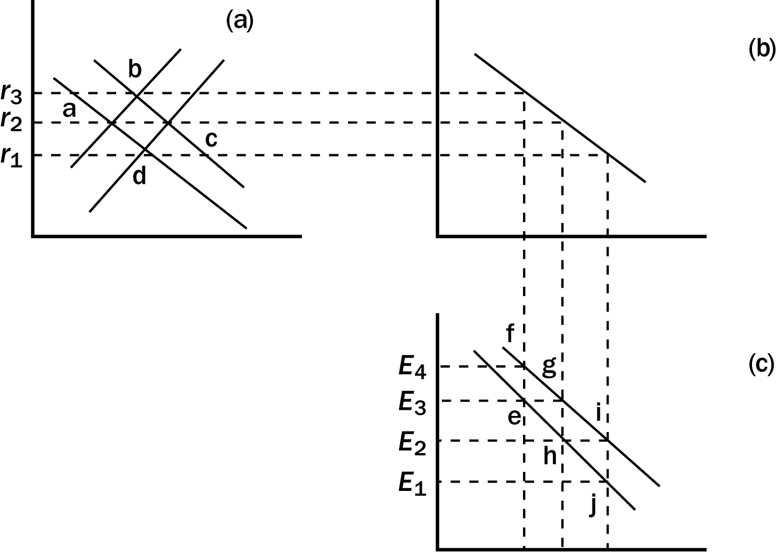
115. Refer to Figure 14-4. The initial effect of an increase in the budget deficit in the loanable funds market is illustrated as a move from
a. a to b.
b. a to c.
c. c to b.
d. c to d.
ANS: C PTS: 1 DIF: 1 REF: 14-3
TOP: Budget deficit | Open-economy macroeconomic model MSC: Applicative
116. Refer to Figure 14-4. In the market for foreign-currency exchange, the effects of an increase in the budget surplus is illustrated as a move from g to
a. e.
b. f.
c. h.
d. i.
ANS: D PTS: 1 DIF: 2 REF: 14-3
TOP: Budget deficit | Open-economy macroeconomic model MSC: Applicative
117. Refer to Figure 14-4. Starting from r₂ and E₃, an increase in the budget deficit can be illustrated as a move to
a. r₁ and E₄.
b. r₁ and E₂.
c. r₃ and E₄.
d. r₃ and E₂.
ANS: C PTS: 1 DIF: 3 REF: 14-3
TOP: Budget deficit | Open-economy macroeconomic model MSC: Analytical
118. Refer to Figure 14-3. Starting from r₂ and E₃, an increase in the budget surplus can be illustrated as a move to
a. r₃ and E₄.
b. r₃ and E₂.
c. r₁ and E₄.
d. r₁ and E₂.
ANS: D PTS: 1 DIF: 2 REF: 14-3
TOP: Budget surplus | Open-economy macroeconomic model MSC: Analytical
119. A trade policy is a government policy
a. directed toward the goal of improving the tradeoff between equity and efficiency.
b. that directly influences the quantity of goods and services that a country imports or exports.
c. intended to exploit the tradeoff between inflation and unemployment by altering the budget deficit.
d. toward trade unions.
ANS: B PTS: 1 DIF: 1 REF: 14-3
TOP: Trade policy | Open-economy macroeconomic model MSC: Definitional
120. A tax on imported goods is called a(n)
a. excise tax.
b. tariff.
c. import quota.
d. None of the above is correct.
ANS: B PTS: 1 DIF: 1 REF: 14-3
TOP: Trade policy | Open-economy macroeconomic model MSC: Definitional
121. A limit on the quantity of a good produced abroad that can be purchased domestically is called a(n)
a. tariff.
b. excise tax.
c. import quota.
d. None of the above is correct.
ANS: C PTS: 1 DIF: 1 REF: 14-3
TOP: Trade policy | Open-economy macroeconomic model MSC: Definitional
122. Which of the following increases if the U.S. imposes an import quota on computer components?
a. U.S. exports
b. U.S. imports
c. U.S. net exports
d. None of the above increases.
ANS: D PTS: 1 DIF: 2 REF: 14-3
TOP: Trade policy | Open-economy macroeconomic model MSC: Applicative
123. U.S.-imposed trade quotas would
a. increase neither net exports, nor net capital outflow.
b. increase net exports, but not net capital outflow.
c. increase net capital outflow, but not net exports.
d. increase net exports and net capital outflow.
ANS: A PTS: 1 DIF: 2 REF: 14-3
TOP: Trade policy | Open-economy macroeconomic model MSC: Applicative
124. If the U.S. were to impose restrictions on imports
a. the demand for loanable funds and the demand for dollars in the market for foreign-currency exchange would both increase.
b. nether the demand for loanable funds nor the demand for dollars in the market for foreign-currency exchange would increase.
c. the demand for loanable funds would increase, but the demand for dollars in the market for foreign-currency exchange would not.
d. the demand for dollars in the market for foreign-currency exchange would increase, but the demand for loanable funds would not.
ANS: D PTS: 1 DIF: 3 REF: 14-3
TOP: Trade policy | Open-economy macroeconomic model MSC: Applicative
125. If the U.S. imposed an import quota on beef, then in the U.S.
a. exports and imports would rise.
b. exports and imports would fall.
c. exports would rise and imports would fall.
d. exports would fall and imports would rise.
ANS: B PTS: 1 DIF: 2 REF: 14-3
TOP: Trade policy | Open-economy macroeconomic model MSC: Applicative
126. If the U.S. put an import quota on vacuum cleaners, it would
a. raise U.S. net exports of vacuum cleaners and raise net exports of other U.S. goods.
b. raise U.S. net exports of vacuum cleaners and lower net exports of other U.S. goods.
c. lower U.S. net exports of vacuum cleaners and raise net exports of other U.S. goods.
d. lower U.S. net exports of vacuum cleaners and lower net exports of other U.S. goods.
ANS: B PTS: 1 DIF: 3 REF: 14-3
TOP: Trade policy | Open-economy macroeconomic model MSC: Analytical
127. If the United States imposes an import quota on clothing, U.S. exports
a. increase, U.S. imports increase, and U.S. net exports are unchanged.
b. increase, U.S. imports decrease, and U.S. net exports increase.
c. decrease, U.S. imports increase, and U.S. net exports decrease.
d. decrease, U.S. imports decrease, and U.S. net exports are unchanged.
ANS: D PTS: 1 DIF: 2 REF: 14-3
TOP: Trade policy | Open-economy macroeconomic model MSC: Analytical
128. In 2002, the United States imposed restrictions on the importation of steel into the United States. Our open-economy macroeconomic model shows that such a policy would
a. lower the real exchange rate and increase net exports.
b. lower the real exchange rate and have no effect on net exports.
c. raise the real exchange rate and decrease net exports.
d. raise the real exchange rate and have no effect on net exports.
ANS: D PTS: 1 DIF: 3 REF: 14-3
TOP: Trade policy | Open-economy macroeconomic model MSC: Analytical
129. In 2002, the United States placed higher tariffs on imports of steel. According to the open-economy macroeconomic model this policy should have
a. reduced imports into the United States and made U.S. net exports rise.
b. reduced imports into the United States and made the net supply of dollars in the foreign exchange market shift right.
c. reduced imports of steel into the United States, but reduced U.S. exports of other goods by an equal amount.
d. reduced imports of steel into the United States and increased U.S. exports of other goods by an equal amount.
ANS: C PTS: 1 DIF: 3 REF: 14-3
TOP: Trade policy | Open-economy macroeconomic model MSC: Applicative
130. Suppose the U.S. imposes an import quota on steel. U.S. exports
a. increase, the real exchange rate of the U.S. dollar appreciates, and U.S. net capital outflow increases.
b. increase, the real exchange rate of the U.S. dollar depreciates, and U.S. net capital outflow is unchanged.
c. decrease, the real exchange rate of the U.S. dollar appreciates, and U.S. net capital outflow is unchanged.
d. decrease, the real exchange rate of the U.S. dollar depreciates, and U.S. net capital outflow decreases.
ANS: C PTS: 1 DIF: 3 REF: 14-3
TOP: Trade policy | Open-economy macroeconomic model MSC: Applicative
131. Suppose that the United States imposes an import quota on automobiles. In the open-economy macroeconomic model this quota shifts the
a. U.S. supply of loanable funds left.
b. U.S. demand for loanable funds left.
c. demand for U.S. dollars in the market for foreign-currency exchange right.
d. supply of U.S. dollars in the market for foreign-currency exchange left.
ANS: C PTS: 1 DIF: 2 REF: 14-3
TOP: Trade policy | Open-economy macroeconomic model MSC: Applicative
132. Suppose that the U.S. imposes an import quota on automobiles. The quota makes the real exchange rate of U.S. dollars
a. appreciate but does not change the real interest rate in the United States.
b. appreciate and the real interest rate in the United States increase.
c. depreciate and the real interest rate in the United States decrease.
d. depreciate but does not change the real interest rate in the United States.
ANS: A PTS: 1 DIF: 3 REF: 14-3
TOP: Trade policy | Open-economy macroeconomic model MSC: Analytical
133. A U.S. imposed quota an agricultural products would shift
a. both the demand and supply curves in the market for foreign-currency exchange right.
b. both the demand and supply curves in the market for foreign-currency exchange right.
c. only the demand curve right.
d. only the supply curve right.
ANS: C PTS: 1 DIF: 2 REF: 14-3
TOP: Trade policy | Open-economy macroeconomic model MSC: Applicative
134. Which of the following is the correct way to show the effects of a newly imposed import quota?
a. Shift the demand for loanable funds right, the supply of dollars in the market for foreign-currency exchange right, and the demand for dollars left.
b. Shift the demand for loanable funds right, and the supply of dollars in the market for foreign-currency exchange left.
c. Shift the demand for dollars in the market for foreign-currency exchange left.
d. None of the above is correct.
ANS: D PTS: 1 DIF: 2 REF: 14-3
TOP: Trade policy | Open-economy macroeconomic model MSC: Applicative
135. Trade policies
a. alter the trade balance because they alter imports of the country that implemented them.
b. alter the trade balance because they alter net capital outflow of the country that implemented them.
c. do not alter the trade balance because they cannot alter the national saving or domestic investment of the country that implements them.
d. do not alter the trade balance because they cannot alter the real exchange rate of the currency of the country that implements them.
ANS: C PTS: 1 DIF: 2 REF: 14-3
TOP: Trade policy | Open-economy macroeconomic model MSC: Interpretive
136. Trade policies
a. affect a country's overall trade balance, but affect all firms and industries the same.
b. affect a country's overall trade balance, but affect some firms or industries differently than others.
c. do not affect a country's overall trade balance, but affect some firms or industries differently than others.
d. do not affect either a country's overall trade balance or specific firms or industries.
ANS: C PTS: 1 DIF: 2 REF: 14-3
TOP: Trade policy | Open-economy macroeconomic model MSC: Interpretive
137. Suppose that the U.S. imposed an import quota on beef. Sales of U.S. beef producers would
a. rise and exports of other industries would increase.
b. rise and exports of other industries would decline.
c. not change, exports of other industries would increase.
d. not change, exports of other industries would decline.
ANS: B PTS: 1 DIF: 2 REF: 14-3
TOP: Trade policy | Open-economy macroeconomic model MSC: Applicative
138. If the U.S. government imposes an import quota on French wine, U.S. net exports will
a. increase, the real exchange rate of the dollar will appreciate, and domestic sales of U.S. wine will increase.
b. not change, the real exchange rate of the dollar will appreciate, and domestic sales of U.S. wine will increase.
c. not change, the dollar will depreciate, and domestic sales of U.S. wine will not change.
d. None of the above is correct.
ANS: B PTS: 1 DIF: 3 REF: 14-3
TOP: Trade policy | Open-economy macroeconomic model MSC: Analytical
139. Which of the following is the most accurate statement?
a. Trade policy has neither microeconomic nor macroeconomic effects.
b. Trade policy has similar microeconomic and macroeconomic effects.
c. The effects of trade policy are more macroeconomic than microeconomic.
d. The effects of trade policy are more microeconomic than macroeconomic.
ANS: D PTS: 1 DIF: 2 REF: 14-3
TOP: Trade policy | Open-economy macroeconomic model MSC: Interpretive
Figure 14-5
140. Refer to Figure 14-5. Which of the following shifts show the effects of an import quota?
a. shifting the middle supply curve in panel c to the one to its left.
b. shifting the demand curve from the right to the left in panel c.
c. shifting the demand curve from the left to the right in panel c.
d. None of the above is correct.
ANS: C PTS: 1 DIF: 1 REF: 14-3
TOP: Trade policy | Open-economy macroeconomic model MSC: Applicative
141. Refer to Figure 14-5. If the interest rate were initially at r₂ and an import quota were imposed, the interest rate would
a. stay at r₂.
b. decrease because supply would shift right.
c. increase because supply would shift left.
d. decrease because demand would shift left.
ANS: A PTS: 1 DIF: 2 REF: 14-3
TOP: Trade policy | Open-economy macroeconomic model MSC: Applicative
142. Refer to Figure 14-5. If the economy were initially in equilibrium at r₂ and E₃ and the government removed import quotas, the exchange rate would
a. appreciate to E₄.
b. appreciate to E₂.
c. depreciate to E₁.
d. depreciate to E₂.
ANS: D PTS: 1 DIF: 2 REF: 14-3
TOP: Trade policy | Open-economy macroeconomic model MSC: Analytical
143. Refer to Figure 14-5. If the economy were initially at the equilibrium marked h and the government imposed quotas on imports of toys and textiles the equilibrium would move to
a. e
b. g
c. i
d. j
ANS: B PTS: 1 DIF: 2 REF: 14-3
TOP: Trade policy | Open-economy macroeconomic model MSC: Analytical
144. Refer to Figure 14-5. If the economy were originally in equilibrium at a and g and the government removed import quotas on toys and textiles the economy would move to
a. b and e.
b. c and h.
c. d and i.
d. None of the above is correct.
ANS: D PTS: 1 DIF: 2 REF: 14-3
TOP: Trade policy | Open-economy macroeconomic model MSC: Analytical
145. A large and sudden movement of funds out of a country is called
a. arbitrage.
b. capital flight.
c. crowding out.
d. capital mobility.
ANS: B PTS: 1 DIF: 2 REF: 14-3
TOP: Capital flight MSC: Definitional
146. Capital flight refers to
a. the movement of workers across international borders in response to exchange rate changes.
b. the movement of funds between financial intermediaries when interest rates change.
c. the ability of foreign direct investment to lift a country out of poverty.
d. a large and sudden movement of funds out of a country.
ANS: D PTS: 1 DIF: 2 REF: 14-3
TOP: Capital flight MSC: Definitional
147. When Mexico suffered from capital flight in 1994, Mexico's net capital outflow
a. and net exports decreased.
b. and net exports increased.
c. increased while net exports decreased.
d. decreased while net exports increased.
ANS: B PTS: 1 DIF: 2 REF: 14-3
TOP: Capital flight MSC: Definitional
148. When Mexico suffered from capital flight in 1994, Mexico's real interest rate
a. fell and the peso appreciated.
b. fell and the peso depreciated.
c. rose and the peso appreciated.
d. rose and the peso depreciated.
ANS: D PTS: 1 DIF: 2 REF: 14-3
TOP: Capital flight MSC: Definitional
149. When Mexico suffered from capital flight in 1994, Mexico's net exports
a. decreased.
b. did not change.
c. increased.
d. decreased until the peso appreciated, then increased.
ANS: C PTS: 1 DIF: 2 REF: 14-3
TOP: Capital flight MSC: Definitional
150. If there is capital flight from the United States, then the demand for loanable funds
a. and the supply of dollars in the foreign-exchange market shift right.
b. and the supply of dollars in the foreign-exchange market shift left.
c. shifts left while the supply of dollars in the foreign-exchange market shifts right.
d. shifts right while the supply of dollars in the foreign-exchange market shifts left.
ANS: A PTS: 1 DIF: 2 REF: 14-3
TOP: Capital flight | Open-economy macroeconomic model MSC: Applicative
151. When a country suffers from capital flight, the demand for loanable funds in that country shifts
a. right, which increases interest rates in that country.
b. right, which decreases interest rates in that country.
c. left, which increases interest rates in that country.
d. left, which decreases interest rates in that country.
ANS: A PTS: 1 DIF: 2 REF: 14-3
TOP: Capital flight | Open-economy macroeconomic model MSC: Analytical
152. When a country experiences capital flight, the interest rate
a. falls because the demand for loanable funds shifts left.
b. falls because the supply for loanable funds shifts right.
c. rises because the demand for loanable funds shifts right.
d. rises because the supply for loanable funds shifts left.
ANS: C PTS: 1 DIF: 2 REF: 14-3
TOP: Capital flight | Open-economy macroeconomic model MSC: Analytical
153. When a country experiences capital flight its currency
a. appreciates and net exports rise.
b. appreciates and net exports fall.
c. depreciates and net exports rise.
d. depreciates and net exports fall.
ANS: C PTS: 1 DIF: 2 REF: 14-3
TOP: Capital flight | Open-economy macroeconomic model MSC: Applicative
154. If Kenya experienced capital flight, the supply of Kenyan schillings in the market for foreign-currency exchange would shift
a. left, which would make the real exchange rate of the Kenyan schilling appreciate.
b. left, which would make the real exchange rate of the Kenyan schilling depreciate.
c. right, which would make the real exchange rate of the Kenyan schilling appreciate.
d. right, which would make the real exchange rate of the Kenyan schilling depreciate.
ANS: D PTS: 1 DIF: 2 REF: 14-3
TOP: Capital flight | Open-economy macroeconomic model MSC: Analytical
155. When Mexico suffered from capital flight in 1994, U.S. demand for loanable funds
a. and U.S. net capital outflow rose.
b. and U.S. net capital outflow fell.
c. fell and U.S. net capital outflow rose.
d. rose and U.S. net capital outflow fell.
ANS: B PTS: 1 DIF: 3 REF: 14-3
TOP: Capital flight | Open-economy macroeconomic model MSC: Analytical
156. When Mexico suffered from capital flight in 1994, the U.S. real interest rate
a. rose and the real exchange rate of the dollar appreciated.
b. rose and the real exchange rate of the dollar depreciated.
c. fell and the real exchange rate of the dollar appreciated.
d. fell and the real exchange rate of the dollar depreciated.
ANS: C PTS: 1 DIF: 2 REF: 14-3
TOP: Capital flight | Open-economy macroeconomic model MSC: Definitional
157. The country of Meditor is politically very stable and has a long tradition of respecting property rights. If several other countries suddenly became politically unstable, we would expect Meditor’s
a. real interest rate to rise.
b. real exchange rate to fall.
c. net exports to fall.
d. None of the above is likely.
ANS: C PTS: 1 DIF: 3 REF: 14-3
TOP: Capital flight | Open-economy macroeconomic model MSC: Analytical
158. Which of the following is most likely to result if foreigners decide to withdraw the funds that they have loaned to the United States over the past two decades?
a. U.S. net exports will rise.
b. U.S. saving will rise.
c. U.S. domestic investment will rise.
d. the dollar will appreciate.
ANS: A PTS: 1 DIF: 3 REF: 14-3
TOP: Capital flight | Open-economy macroeconomic model MSC: Analytical
159. In 1995 House Speaker Newt Gingrich threatened to send the United States into default on its debt. During the day of this announcement, U.S. interest rates rose and the real exchange rate of the U.S. dollar depreciated. Which of these changes is consistent with the results of the open-economy macroeconomic model?
a. the increase in U.S. interest rates
b. the depreciation of the real exchange rate of the U.S. dollar
c. Both a and b are consistent.
d. Neither a nor b are consistent.
ANS: C PTS: 1 DIF: 3 REF: 14-3
TOP: Capital flight | Open-economy macroeconomic model MSC: Analytical
160. In 2002 it looked like the Argentinean government might default on its debt (which eventually it did). The open-economy macroeconomic model predicts that this should have
a. raised Argentinean interest rates and caused the Argentinean currency to appreciate.
b. raised Argentinean interest rates and caused the Argentinean currency to depreciate.
c. lowered Argentinean interest rates and caused the Argentinean currency to appreciate.
d. lowered Argentinean interest rates and caused the Argentinean currency to depreciate.
ANS: B PTS: 1 DIF: 2 REF: 14-3
TOP: Capital flight | Open-economy macroeconomic model MSC: Analytical
161. The 1998 default by the Russian government had results that were predictable using the textbook model. The default
a. increased Russian interest rates and net exports.
b. reduced Russian interest rates and net exports.
c. increased Russian interest rates and reduced Russian net exports.
d. reduced Russian interest rates and increased Russian net exports.
ANS: A PTS: 1 DIF: 3 REF: 14-3
TOP: Capital flight | Open-economy macroeconomic model MSC: Analytical
The diagram below represents the market for loanable funds and the market for foreign-currency exchange in Mexico. Use the diagram to answer the following questions.
Figure 14-6
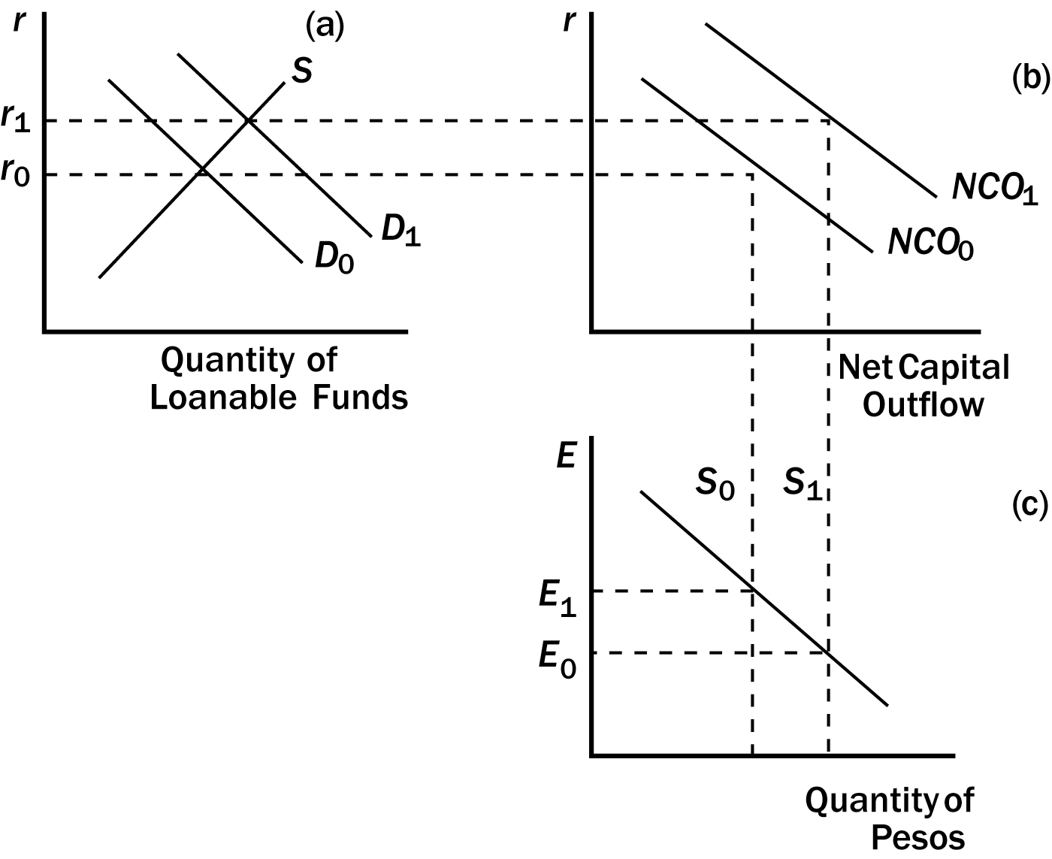
162. Refer to Figure 14-6. Supposing that the Mexican economy starts at r₀ and E₁. Which of the following is consistent with the effects of capital flight?
a. the shift from D₀ to D₁ in Panel A
b. the shift from NCO₀ to NCO₁ in Panel B
c. the shift from S₀ to S₁ in Panel C
d. All of the above shifts are consistent with the effects of capital flight.
ANS: D PTS: 1 DIF: 2 REF: 14-3
TOP: Capital flight | Open-economy macroeconomic model MSC: Applicative
163. Refer to Figure 14-6. Which of the following is consistent with capital flight from Mexico?
a. The real exchange rate of the peso appreciates from E₀ to E₁.
b. The real exchange rate of the peso depreciates from E₀ to E₁.
c. The real exchange rate of the peso appreciates from E₁ to E₀.
d. The real exchange rate of the peso depreciates from E₁ to E₀.
ANS: D PTS: 1 DIF: 2 REF: 14-3
TOP: Capital flight | Open-economy macroeconomic model MSC: Analytical
164. Refer to Figure 14-6. Suppose the Mexican economy starts at r₀ and E₁. Which of the following new equilibrium is consistent with capital flight?
a. r_{o} and E₀
b. r₁ and E₀
c. r₁ and E₁
d. None of the above is correct.
ANS: B PTS: 1 DIF: 2 REF: 14-3
TOP: Capital flight | Open-economy macroeconomic model MSC: Analytical
165. Which of the following would cause the real exchange rate of the U.S. dollar to depreciate?
a. the U.S. government budget deficit increases
b. capital flight from the United States
c. the U.S. imposes import quotas
d. None of the above is correct.
ANS: B PTS: 1 DIF: 3 REF: 14-3
TOP: Open-economy macroeconomic model MSC: Analytical
166. Which of the following would both raise the U.S. exchange rate?
a. capital flight from other countries to the U.S. occurs and the U.S. moves from budget surplus to budget deficit
b. capital flight from other countries to the U.S. occurs and the U.S. moves from budget deficit to budget surplus
c. capital flight from the U.S. to other countries occurs, the U.S. moves from budget surplus to budget deficit
d. capital flight from U.S. to other countries occurs, the U.S. moves from budget deficit to budget surplus
ANS: A PTS: 1 DIF: 3 REF: 14-3
TOP: Capital flight | Budget deficit MSC: Analytical
167. Which of the following will not change the U.S. real interest rate?
a. capital flight from the United States
b. the government budget deficit increases
c. the U.S. imposes import quotas
d. None of the above is correct.
ANS: C PTS: 1 DIF: 2 REF: 14-3
TOP: Open-economy macroeconomic model MSC: Analytical
168. Which of the following will decrease U.S. net capital outflow?
a. capital flight from the United States
b. the government budget deficit increases
c. the U.S. imposes import quotas
d. None of the above is correct.
ANS: B PTS: 1 DIF: 2 REF: 14-3
TOP: Open-economy macroeconomic model MSC: Applicative
169. Which of the following is most likely to increase U.S. exports?
a. The government gives subsidies to U.S. firms that export goods or services.
b. The government reduces the size of the budget surplus.
c. The United States unilaterally reduces its restrictions on foreign imports.
d. Taxes on domestic saving rise.
ANS: C PTS: 1 DIF: 3 REF: 14-3
TOP: Open-economy macroeconomic model MSC: Analytical
170. Which of the following is most likely to increase the exports of a country?
a. The government gives subsidies to firms that export goods or services.
b. The government reduces the size of the budget surplus.
c. Political instability within the country increases modestly.
d. None of the above will increase exports.
ANS: C PTS: 1 DIF: 3 REF: 14-3
TOP: Open-economy macroeconomic model MSC: Analytical
171. Which of the following would do the most to reduce a trade deficit?
a. Increase domestic saving.
b. Increase political stability and respect for property rights.
c. Negotiate with other countries to get them to reduce their trade restrictions.
d. Impose higher tariffs on imported goods.
ANS: A PTS: 1 DIF: 3 REF: 14-3
TOP: Open-economy macroeconomic model MSC: Analytical
172. Which of the following is most likely to increase exports?
a. a reduction in political instability
b. ending investment tax credits
c. a reduction in the size of the government's budget surplus
d. None of the above will increase exports.
ANS: B PTS: 1 DIF: 3 REF: 14-3
TOP: Open-economy macroeconomic model MSC: Analytical
173. If U.S. citizens decide to save a larger fraction of their incomes, the real interest rate
a. decreases, the real exchange rate of the dollar depreciates, and U.S. net capital outflow increases.
b. decreases, the real exchange rate of the dollar appreciates, and U.S. net capital outflow decreases.
c. increases, the real exchange rate of the dollar appreciates, and U.S. net capital outflow decreases.
d. increases, the real exchange rate of the dollar depreciates, and U.S. net capital outflow increases.
ANS: A PTS: 1 DIF: 2 REF: 14-3
TOP: Open-economy macroeconomic model MSC: Analytical
174. If U.S. citizens decide to save a smaller fraction of their incomes, U.S. domestic investment
a. increases, and U.S. net capital outflow increases.
b. increases, and U.S. net capital outflow decreases.
c. decreases, and U.S. net capital outflow increases.
d. decreases, and U.S. net capital outflow decreases.
ANS: D PTS: 1 DIF: 2 REF: 14-3
TOP: Open-economy macroeconomic model MSC: Analytical
175. If government policy encouraged households to save more at each interest rate, then
a. the real exchange rate and net exports would rise.
b. the real exchange rate and net exports would fall.
c. the real exchange rate would rise and net exports would fall.
d. the real exchange rate would fall and net exports would rise.
ANS: D PTS: 1 DIF: 2 REF: 14-3
TOP: Saving policy | Open-economy macroeconomic model MSC: Analytical
176. If U.S. citizens decide to purchase more foreign assets at each interest rate, the U.S. real interest rate
a. increases, the real exchange rate of the dollar appreciates, and U.S. net capital outflow decreases.
b. increases, the real exchange rate of the dollar depreciates, and U.S. net capital outflow increases.
c. decreases, the real exchange rate of the dollar depreciates, and U.S. net capital outflow decreases.
d. decreases, the real exchange rate of the dollar appreciates, and U.S. net capital outflow increases.
ANS: B PTS: 1 DIF: 3 REF: 14-3
TOP: Saving in an open economy | Open-economy macroeconomic model MSC: Analytical
177. If U.S. firms decide to invest more domestically at each interest rate, the real interest rate in the United States
a. decreases, the real exchange rate of the dollar depreciates, and U.S. net capital outflow decreases.
b. decreases, the real exchange rate of the dollar appreciates, and U.S. net capital outflow increases.
c. increases, the real exchange rate of the dollar appreciates, and U.S. net capital outflow decreases.
d. increases, the real exchange rate of the dollar depreciates, and U.S. net capital outflow increases.
ANS: C PTS: 1 DIF: 3 REF: 14-3
TOP: Open-economy macroeconomic model MSC: Analytical
True/False
1. Over the past decade, the United States has persistently exported more goods and services than it has imported.
ANS: F PTS: 1 DIF: 1 REF: 14-1
TOP: Budget deficit MSC: Analytical
2. In the open-economy macroeconomic model we focus on the determination of GDP and the price level.
ANS: F PTS: 1 DIF: 1 REF: 14-1
TOP: Open-economy macroeconomic model MSC: Definitional
3. In an open economy, the supply of loanable funds comes from national saving.
ANS: T PTS: 1 DIF: 1 REF: 14-1
TOP: Market for loanable funds MSC: Definitional
4. In an open economy, the demand for loanable funds comes from both domestic investment and net capital outflow.
ANS: T PTS: 1 DIF: 1 REF: 14-1
TOP: Market for loanable funds MSC: Definitional
5. A drop in the Peruvian real interest rate reduces Peruvian net capital outflow.
ANS: F PTS: 1 DIF: 2 REF: 14-1
TOP: Net capital outflow MSC: Applicative
6. In the open-economy macroeconomic model, at the equilibrium real interest rate, the amount that people (including government) want to save exactly balances desired domestic investment.
ANS: F PTS: 1 DIF: 1 REF: 14-1
TOP: Market for loanable funds MSC: Definitional
7. If the real interest rate were above the equilibrium rate, there would be a shortage of loanable funds.
ANS: F PTS: 1 DIF: 1 REF: 14-1
TOP: Market for loanable funds MSC: Applicative
8. Net capital outflow represents the quantity of dollars supplied in the foreign-currency exchange market.
ANS: T PTS: 1 DIF: 1 REF: 14-1
TOP: Market for foreign-currency exchange MSC: Definitional
9. In the open-economy macroeconomic model, net exports equal the quantity of dollars demanded in the foreign-currency exchange market.
ANS: T PTS: 1 DIF: 1 REF: 14-1
TOP: Market for foreign-currency exchange MSC: Definitional
10. Other things the same, when the real exchange rate of the dollar appreciates, U.S. goods become more attractive to U.S. residents, but less attractive to foreign residents.
ANS: F PTS: 1 DIF: 2 REF: 14-1
TOP: Market for foreign-currency exchange MSC: Analytical
11. In the open-economy macroeconomic model, the supply curve of currency is vertical because the quantity of currency supplied does not depend on the real exchange rate.
ANS: T PTS: 1 DIF: 1 REF: 14-1
TOP: Market for foreign-currency exchange MSC: Applicative
12. If the real exchange rate of the U.S. dollar were above its equilibrium level, the real exchange rate of the U.S. dollar would appreciate.
ANS: F PTS: 1 DIF: 1 REF: 14-1
TOP: Market for foreign-currency exchange MSC: Analytical
13. In the open-economy macroeconomic model, other things the same, when a U.S. resident imports a foreign good, our model treats this as a decrease in the demand for dollars in the foreign-currency exchange market.
ANS: T PTS: 1 DIF: 2 REF: 14-2
TOP: Market for foreign-currency exchange MSC: Applicative
14. The key determinant of net capital outflow is the real exchange rate.
ANS: F PTS: 1 DIF: 2 REF: 14-1
TOP: Net capital outflow MSC: Applicative
15. Because depreciation of the real exchange rate of the dollar increases U.S. net exports, the demand curve for dollars in the foreign-currency exchange market is downward sloping.
ANS: T PTS: 1 DIF: 2 REF: 14-1
TOP: Market for foreign-currency exchange MSC: Interpretive
16. Other things the same, when an Australian company imports sporting equipment from the U.S., the open-economy macroeconomic model treats this transaction as an increase in the quantity of dollars demanded in the U.S. foreign-currency exchange market.
ANS: T PTS: 1 DIF: 2 REF: 14-2
TOP: Market for foreign-currency exchange MSC: Interpretive
17. In the open-economy macroeconomic model, net capital outflow links the markets for loanable funds and foreign-currency exchange.
ANS: T PTS: 1 DIF: 1 REF: 14-2
TOP: Open-economy macroeconomic model MSC: Definitional
18. When the government increases the government budget deficit, national saving decreases.
ANS: T PTS: 1 DIF: 1 REF: 14-3
TOP: Market for loanable funds MSC: Definitional
19. According to the open-economy macroeconomic model, if the U.S. government reduced its government budget deficit, both U.S. domestic investment and U.S. net capital outflow would fall.
ANS: F PTS: 1 DIF: 2 REF: 14-3
TOP: Budget deficit | Open-economy macroeconomic model MSC: Analytical
20. According to the open-economy macroeconomic model, an increase in the U.S. government budget surplus increases U.S. net capital outflow, causes the real exchange rate of the dollar to depreciate, and increases U.S. net exports.
ANS: T PTS: 1 DIF: 2 REF: 14-3
TOP: Budget surplus | Open-economy macroeconomic model MSC: Analytical
21. According to the open-economy macroeconomic model, if the United States moved from a government budget deficit to a government budget surplus, U.S. real interest rates would increase and the real exchange rate of the U.S. dollar would appreciate.
ANS: F PTS: 1 DIF: 2 REF: 14-3
TOP: Open-economy macroeconomic model MSC: Analytical
22. In the 1980s, both the U.S. budget and U.S. trade deficit increased.
ANS: T PTS: 1 DIF: 1 REF: 14-3
TOP: U.S. trade MSC: Definitional
23. When a country imposes a trade restriction, the real exchange rate of that country's currency appreciates.
ANS: T PTS: 1 DIF: 1 REF: 14-3
TOP: Trade policy | Open-economy macroeconomic model MSC: Applicative
24. An import quota imposed by Egypt would reduce Egyptian imports, but have no impact on Egyptian exports.
ANS: F PTS: 1 DIF: 2 REF: 14-3
TOP: Trade policy | Open-economy macroeconomic model MSC: Analytical
25. Although trade policies do not affect a country's overall trade balance, they do affect specific firms and industries.
ANS: T PTS: 1 DIF: 2 REF: 14-3
TOP: Trade policy MSC: Applicative
26. If policymakers impose import restrictions on electronics, the U.S. trade deficit will shrink.
ANS: F PTS: 1 DIF: 2 REF: 14-3
TOP: Trade policy | Open-economy macroeconomic model MSC: Applicative
27. If Argentina suffers from capital flight, Argentinean domestic investment will fall and Argentinean net exports will increase.
ANS: T PTS: 1 DIF: 2 REF: 14-3
TOP: Capital flight | Open-economy macroeconomic model MSC: Analytical
Short Answer
1. Explain why saving need not equal domestic investment in an open economy.
ANS:
Because saving equals domestic investment plus net capital outflow. If net capital outflow is not equal to zero, then domestic saving does not equal domestic investment.
PTS: 1 DIF: 2 REF: 14-1
TOP: Saving in an open economy MSC: Interpretive
2. Why do higher real interest rates lead to lower net capital outflow?
ANS:
Higher U.S. interest rates make U.S. assets look more attractive than foreign assets. Investors in the United States and other countries are likely to move funds into the United States, reducing U.S. net capital outflow.
PTS: 1 DIF: 2 REF: 14-1
TOP: Net capital outflow MSC: Analytical
3. State what, if anything, each of the following does to the supply or demand of loanable funds.
a. net capital outflow increases at each interest rate
b. domestic investment increases at each interest rate
c. the government deficit increases
d. private saving increases
ANS:
a. the demand for loanable funds increases
b. the demand for loanable funds increases
c. the supply of loanable funds decreases
d. the supply of loanable funds increases
PTS: 1 DIF: 2 REF: 14-1
TOP: Market for loanable funds MSC: Analytical
4. Suppose that U.S. investors decide that investment opportunities in African countries have improved. What happens to U.S. net capital outflow? What happens to the U.S. real interest rate?
ANS:
U.S. net capital outflow will increase. The increase in net capital outflow increases the U.S. demand for loanable funds, which increases U.S. interest rates.
PTS: 1 DIF: 2 REF: 14-1
TOP: Net capital outflow MSC: Applicative
5. Explain how the relation between the real exchange rate and net exports explains the downward slope of the demand for foreign-currency exchange curve.
ANS:
When the U.S. real exchange rate appreciates, U.S. goods become more expensive relative to foreign goods. This induces U.S. citizens to buy more goods overseas, which increases U.S. imports. The appreciation also induces foreign citizens to buy fewer U.S. goods, so U.S. exports fall. The decline in exports and increase in imports decreases net exports, and so the demand for U.S. dollars declines. The inverse relation between the exchange rate and the quantity of U.S. dollars demanded in the foreign-currency exchange market is represented by the downward-sloping demand curve.
PTS: 1 DIF: 2 REF: 14-1
TOP: Market for foreign-currency exchange MSC: Interpretive
6. How are the identities S = NCO + I and NCO = NX related to the foreign currency exchange market and the loanable funds market?
ANS:
S is national saving, which is the source of loanable funds supply. NCO + I is net capital outflow plus domestic investment, which is the source of demand in the loanable funds market. NCO is the source of supply in the foreign-currency exchange market. NX is net exports, which is the source of demand in the foreign-currency exchange market.
PTS: 1 DIF: 2 REF: 14-1
TOP: Saving in an open economy | Open-economy macroeconomic model MSC: Interpretive
7. Suppose that U.S. citizens start saving more. What does this imply about the supply of loanable funds and the equilibrium real interest rate? What happens to the real exchange rate?
ANS:
The supply of loanable funds increases, and the equilibrium real interest rate falls. Because of the lower interest rate, U.S. net capital outflow rises. This increase makes the supply of dollars shift to the right, and the real exchange rate of the dollar depreciates.
PTS: 1 DIF: 2 REF: 14-3
TOP: Open-economy macroeconomic model MSC: Analytical
8. Suppose that the Turkish government budget deficit increases. What curves in the open-economy macroeconomic model shift? Explain why each curve shifts the direction it does.
ANS:
The supply of Turkish loanable funds curve shifts left because the government deficit decreases national saving. As the supply of loanable funds shifts left, the Turkish interest rate rises. This increase in the interest rate causes the quantity of Turkish net capital outflow to fall, which means that people will be supplying fewer Turkish dinar in order to purchase foreign assets. So the supply of dinar in the foreign-currency exchange market shifts left.
PTS: 1 DIF: 2 REF: 14-3
TOP: Budget deficit | Open-economy macroeconomic model MSC: Analytical
9. Suppose a presidential candidate promises to increase the government budget surplus and claims that doing so will stop U.S. citizens from investing in foreign companies and increase the value of the dollar. Evaluate this promise.
ANS:
An increase in the government budget surplus will cause U.S. interest rates to fall. The decline in interest rates will increase domestic investment, but it will also cause Americans to look for higher returns abroad, which means that net capital outflow rises rather than falls as promised. To take advantage of these higher returns, Americans will supply more dollars in the foreign-currency exchange market and the dollar will depreciate rather than appreciate as promised.
PTS: 1 DIF: 3 REF: 14-3
TOP: Budget surplus | Open-economy macroeconomic model MSC: Analytical
10. What effect do protectionist policies have on the trade deficit?
ANS:
Protectionist policies increase the demand for U.S. dollars, and so lead to an appreciation of the real exchange rate for U.S. dollars. However, the policies have no impact on either the supply of loanable funds or the demand for loanable funds, and so they have no effect on net capital outflow. Since net capital outflow must equal net exports, there is also no change in net exports. The appreciation of the dollar therefore leads to falling net exports, which offsets the rise in net exports that protectionist policies would otherwise create.
PTS: 1 DIF: 2 REF: 14-3
TOP: Trade policy | Open-economy macroeconomic model MSC: Analytical
11. Suppose the U.S. government institutes a "Buy American" campaign, in order to encourage spending on domestic goods. What effect will this have on the U.S. trade balance?
ANS:
Such a campaign will increase the demand for domestically produced goods and hence decrease the demand for imports. This increases the demand for dollars in the market for foreign currency. The real exchange rate of the U.S. dollar will appreciate, and the net effect will be no change in the trade balance. The level of net exports ultimately depends upon domestic saving and investment, neither of which are affected by the campaign.
PTS: 1 DIF: 2 REF: 14-3
TOP: Trade policy | Open-economy macroeconomic model MSC: Analytical
12. What do trade policies do to the standard of living?
ANS:
Trade policies reduce both imports and exports. While they leave the trade balance unchanged, they reduce trade overall and so reduce the gains from trade. This lowers the standard of living. U.S. industries that produce goods on which imports are reduced may gain, but overall there is a loss.
PTS: 1 DIF: 3 REF: 14-3
TOP: Trade policy MSC: Analytical
13. Fill in the table below with the direction of the variables that change in response to the events in the first column.

 | U.S. real  interest rate | U.S. domestic  investment | U.S. net  capital  outflow | U.S. real  exchange rate  of domestic  currency | U.S. trade  balance
U.S. government
budget deficit
increases
U.S. imposes
import quotas

capital flight
from the United
States

ANS:
 | U.S. real  interest rate | U.S. domestic  investment | U.S. net  capital  outflow | U.S. real  exchange rate  of domestic  currency | U.S. trade  balance
U.S. government  budget deficit  increases | rises | falls | falls | appreciates | falls
U.S. imposes  import quotas | no change | no change | no change | appreciates | no change
capital flight  from the United  States | rises | falls | rises | depreciates | rises

PTS: 1 DIF: 3 REF: 14-3
TOP: Open-economy macroeconomic model MSC: Analytical

